Introduction
UCD has introduced an online system for the reporting of incidents called iProtectU. This system replaces the previously used pdf forms.
This short guide is designed to help system users to navigate the system to report incidents easily, quickly and accurately. This is whether you're reporting an incident that happened to you or reporting on behalf of someone else. Staff and Research Postgraduate Students can access this system using their UCD Connect login details
All incidents resulting in personal injury, near misses or damage to property must be notified to the SIRC Office promptly via the online portal to ensure that the University is compliant in fulfilling its statutory accident reporting duties.
What you will learn
How to access and log into the iProtectU platform:
- Step-by-step instructions for submitting an incident report
- Tips for describing incidents clearly and considerately
- How to attach supporting evidence or documents
- What happens after your report is submitted
Step 1: Logging In
- Access the UCD online incident report form (iProtectU) via UCD Connect.
- Log in using your university credentials.
- 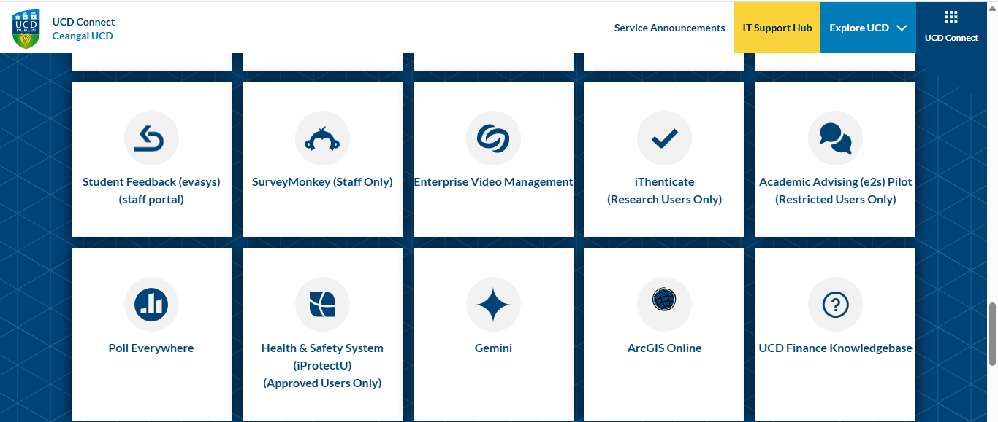

💡 Tip: Add the portal to your favourites bar for quick access.
- Navigate to the Incident Reporting section from the main dashboard.
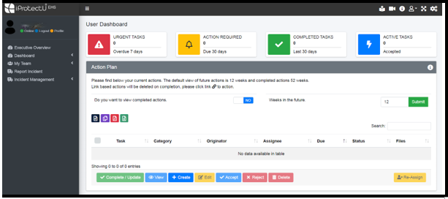

- Click on "Report Incident" in the left-hand side menu, as shown above.
- Click "Submit a Report”:
N.B. DO NOT CREATE A TASK, USE THE REPORT INCIDENT BUTTON
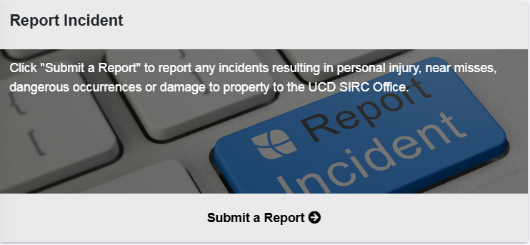

Step 2: Reporting for Yourself or Someone Else
- Choose whether you are reporting an incident involving yourself or another person.
- If reporting for someone else, slide the button next to “Report on behalf of Student and Other Persons” to “Yes.”
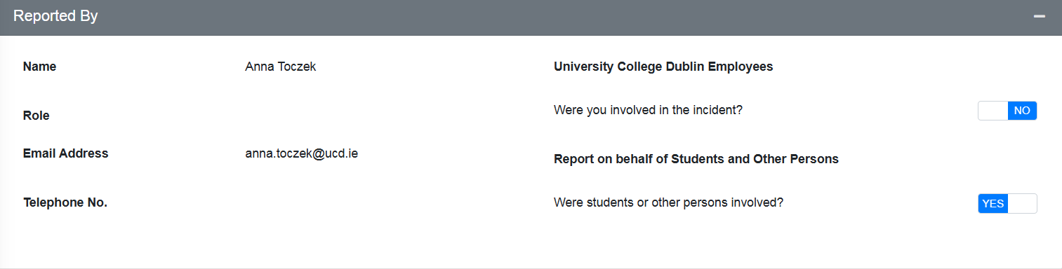

- Enter their details carefully.
🧠 Accurate identification helps ensure the right support is provided.

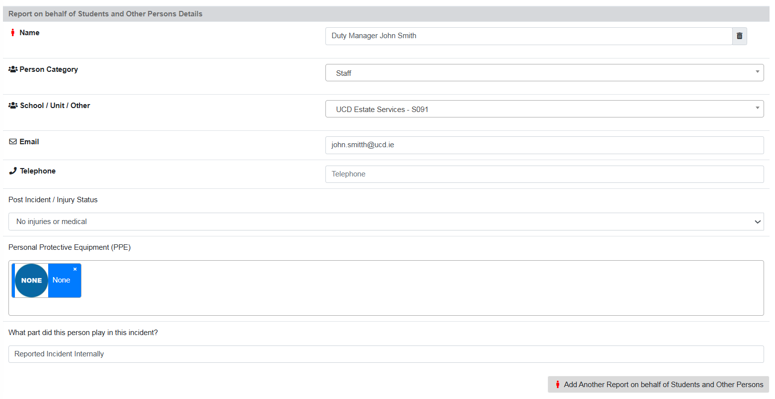

- Select ‘Post Incident’ and the injury status will pop up for Injury Type Selection and describe the injury. Also indicate the injury location in the diagram below:

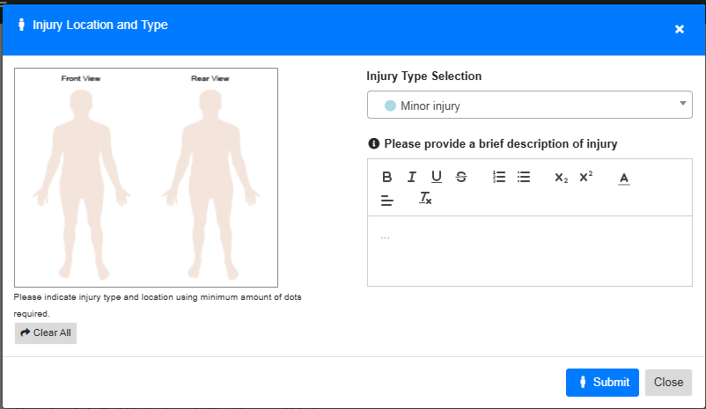

- Witness – Add the details of all people who witnessed the incident.
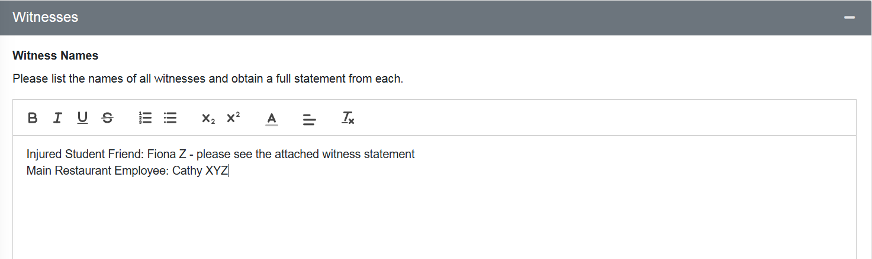

Step 3: Describing the Incident
- Enter the time, address and select all External Authorities involved:

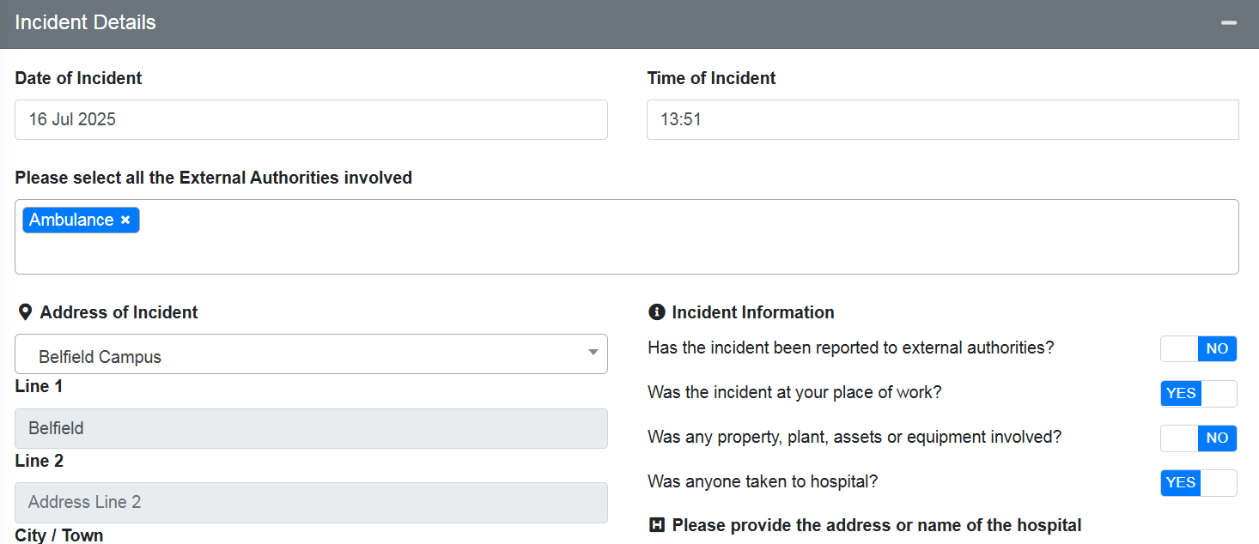

- Provide a clear, factual account of what happened:
✍️ Example:
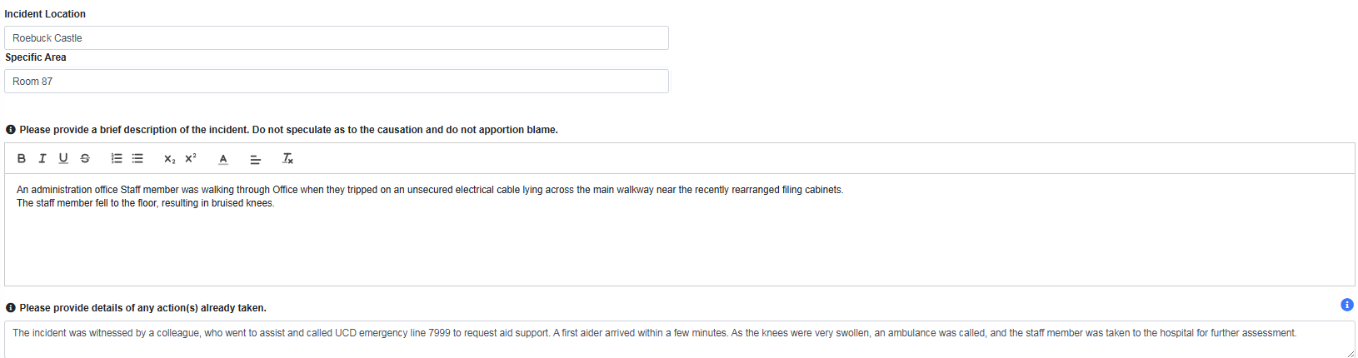

- Complete the Additional Questions to the best of your knowledge about the incident:
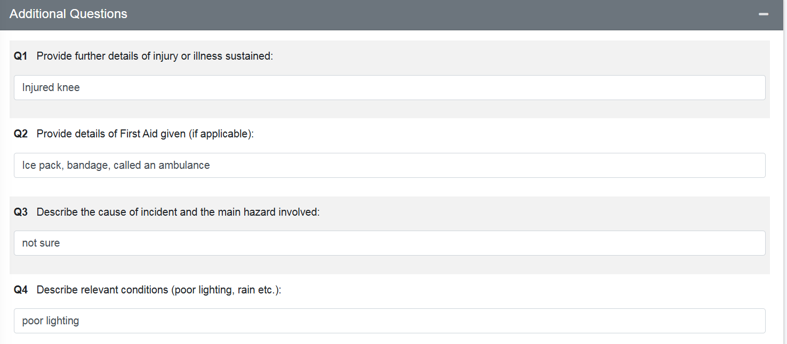
- If the question “Was any property, plant, assets, or equipment involved?” in the Incident Information section is answered Yes, complete the appropriate section: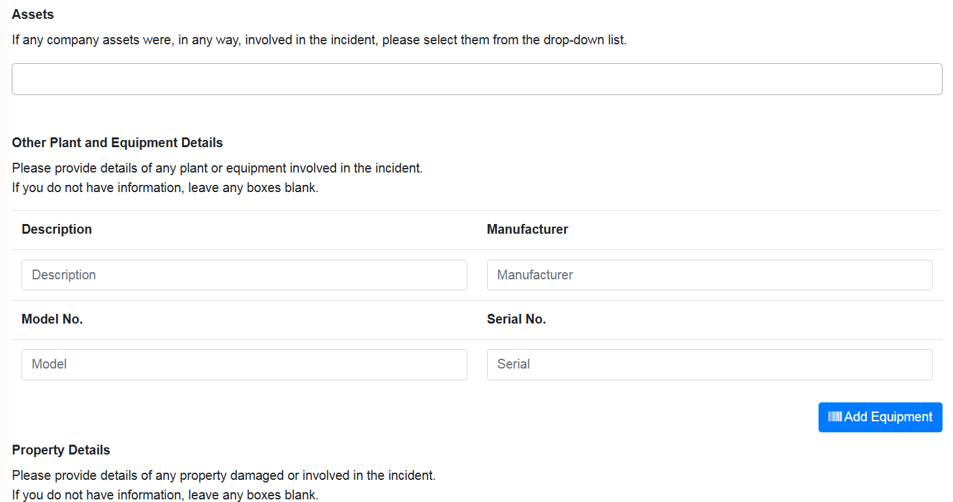

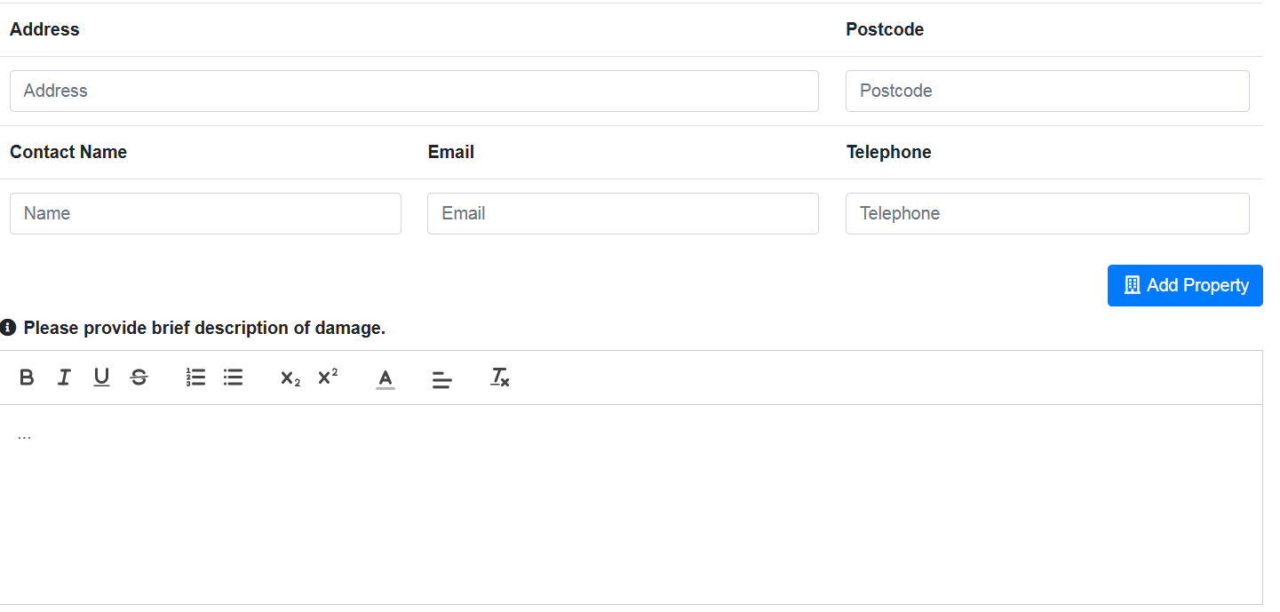
Step 4: Adding Supporting Information
- Upload any relevant documents, photos, or witness statements.
- Use the attachment tool to include files directly in the report.
- Confirm that all uploads are complete before submitting.
📷 Photos of the location or screenshots of messages (if relevant) can be useful.
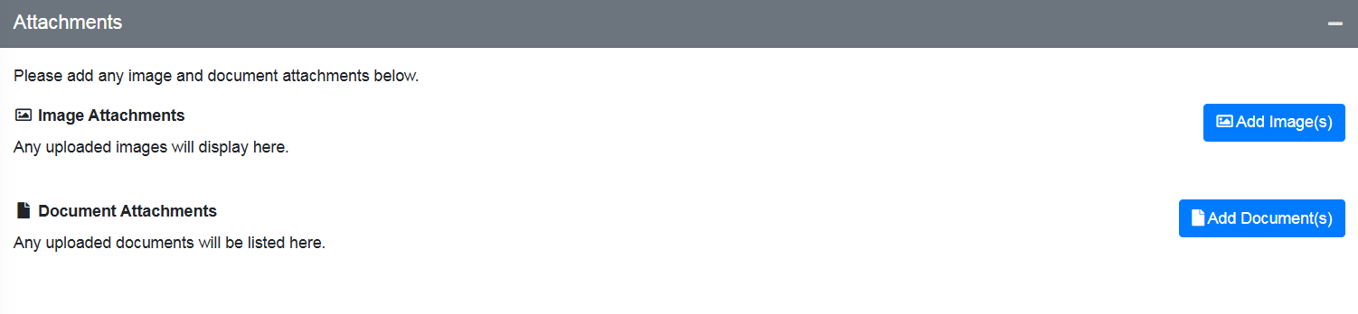

Step 5: Final Review and Submission
- Review all fields for accuracy.
- Click Submit to send the report.
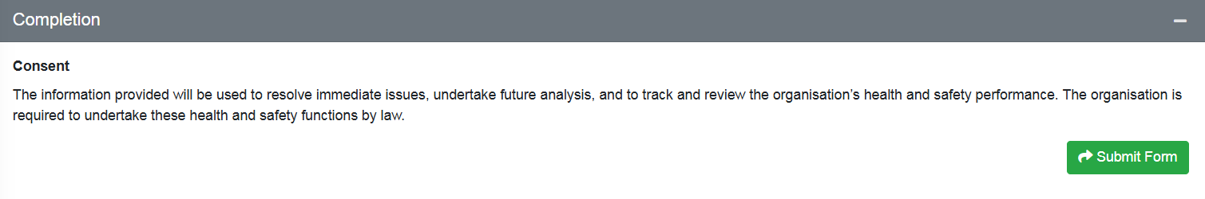

What Happens Next?
Once submitted:
- The UCD SIRC Office receives a notification of the incident report and will initiate their investigation procedures.
- Support or follow-up actions will be taken based on the nature of the incident.
🛠️ Your report helps identify risks and improve safety across the campus.

Further information
- Further information on accessing the system, FAQs, guidelines and reporting incidents is available on the SIRC Office website.

Note: The content and data shown in the above pictures are illustrative and intended solely for training purposes. Should you require further information or additional training, please contact SIRC directly at sirc@ucd.ie

